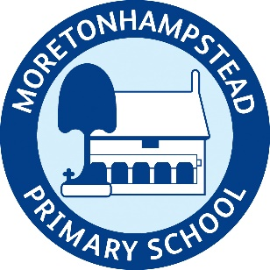
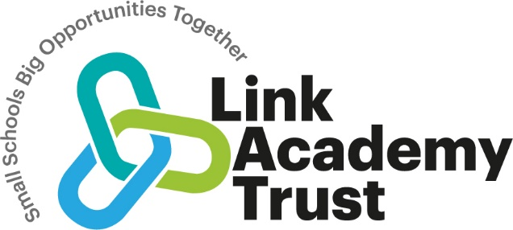
Moretonhampstead Primary School
PSHE & RSE Curriculum Plan

Intent
PSHE is at the core of what we do and enables our children to become independent, confident, healthy and responsible members of society, as well as developing the whole child: intellectually, morally, socially and spiritually. Our PSHE curriculum equips children with relevant and meaningful content, which is supported through a strong emphasis on emotional literacy, building resilience and nurturing mental and physical health. With an ever-changing society, we can provide our children with a strong understanding of the diverse world around them and support them in playing a positive role in contributing to the school and the wider community.

Jigsaw
We have chosen a curriculum scheme that is constantly reviewed and evolved within the current climate. It covers all the requirements of government guidance and outcomes. Jigsaw allows children to revisit common themes throughout their school journey and is an interactive tool which can be used across the whole school community.

Implementation
Progression of Skills and Vocabulary

Please click on the link: Jigsaw 2026-3-11-progression-of-skills-and-vocab-map.docx
Children will develop the ability to apply subject specific vocabulary in PSHE and RSHE through consistent modelling by staff whilst establishing a culture of high expectations for discussion and debates.

At Moretonhampstead, we introduce the same theme through a whole school assembly at the beginning of each half term. The themes for each term are:

Autumn 1 Being Me in My World
Autumn 2 Celebrating Difference (Including anti-bullying)
Spring 1 Dreams and Goals
Spring 2 Healthy Me
Summer 1 Relationships
Summer 2 Changing Me (Including Sex Education)

Our long-term curriculum plan for PSHE has been carefully planned to take note of the mixed age classes at Moretonhampstead and follows a rolling programme for the Jigsaw termly themes. As a staff, we teach the ‘Changing Me’ Summer 2 theme is taught to the children in their respective age groups to ensure that the material is age appropriate for the pupils taught. This theme also covers our teaching of sex education.

Assessment is guided by the Jigsaw programme. The initial jigsaw lesson per puzzle piece begins with an elicitation task, either individual or whole class, to judge prior knowledge. Teachers regularly assess their pupils to judge the impact of teaching and learning in PSHE and RSHE and adapt planning to suit need.

Children’s progress is monitored using end of unit summative comments, ’I can’ statements, under the headings of working towards/ working at/ working beyond. Judgement is informed through using dialogue, class scrapbooks/sway, the child’s individual jigsaw journal and Tapestry.
Impact
Children at Moretonhampstead acquire an understanding of British Values and Protected Characteristics that are necessary if they are to make sense of their experiences, value themselves, respect others, appreciate differences and feel confident and informed as a British citizen. Our children are encouraged to support and work alongside our school community for example: singing for local pensioners, raising money for charity and organising community events. The attitude and conduct of our children when off-site is invariably positively commented upon. Our weekly celebration assembly recognises a range of achievements such as ‘Marvellous Manners’ which foster the school’s wider work in recognising pupils as good citizens alongside academic achievement. House points are celebrated in our celebration assembly together with class ‘Stars of the Week’ and recognition of sporting and personal achievements taking place both in and out of school.

PSHE Provision will also be informed and influenced by national themes and special days such as Safer Internet Day, Mental Health Week, Anti Bullying/Friendship Week, Random Acts of Kindness, our student council and numerous community events. We also work alongside agencies such as NSPCC. This gives feedback to teachers about aspects of social and emotional well-being of the pupils in their respective classes and suggested areas of focus. Year 6 also hold an annual ‘Grow £5 project’ to support children’s monetary understanding and future economic well-being.

Please also see our Personal Development and Well-being document.
Personal Development and Well-Being.docx

