Personal, Social and Emotional Development:
Can talk about the feelings ‘happy’ and ‘sad’
Recognises when they might be ‘happy’ or ‘sad’ and responds appropriately
Children celebrate accomplishment of goals
Understands that they need to wait their turn, using props to support them
Selects and uses activities and resources, with help, when needed.
Knows that they need some resources e.g. an apron for painting.
Sometimes shares resources with adults and peers, sometimes requiring support
Recognises their own belongings and knows to store their items on their peg
Can talk about the feelings ‘jealous’, ‘worried’ and ‘frightened’ and is aware of synonyms for previously learnt feelings
Recognises the feelings of characters in stories
Children are able to explain what they are good at and what they need to practise
Children are developing resilience, trying to do something difficult which they want to achieve
Takes turns in games and group activities with some support
Shows confidence when playing in a small group and in new social situations
Children increasingly follow rules independently
Shares resources with friends if they are asked for something
Resolving conflicts by themselves, where possible, and not retaliating
Developing appropriate ways of being assertive

Physical Development:
Children will have a PE lesson with Mr Pierce on a Tuesday where they will be developing ‘Fundamental movements.
Gross:
Rides a trike independently
Can throw a large ball with both hands
Catches a large ball from a short distance
Uses large-muscle movements to produce vertical and horizontal lines
Uses small-muscle movements to produce vertical and horizontal lines
Is aware of healthy and unhealthy foods
Independently accesses the outdoor area for exercise and knows why we need to exercise
Rides a balance bike, occasionally lifting up their feet
Skip, hop, stand on one leg and hold a pose
Walks along a bench independently
Uses large-muscle movements to produce squares
Uses small-muscle movements to produce squares
Fine
Begin to use scissors. Uses large tweezers, large nuts and bolts and is able to thread. Is able to use other large one-handed tools such as hammers
Uses Static tripod/quad grasp
Beginning to show strength in a particular hand
Use a comfortable grip with good control
Dynamic tripod grasp
Put their coat on by themselves and zip it up

How do I express myself?
Colours
Little Tors
OUR learning map
term – Autumn 1 – 2023
Pre-school & Reception


Communication and Language:
Listens to simple stories with a picture stimulus
Is beginning to listen to adults and other children
Communicates with survival language and with 1 or 2 words at a time
Children can articulate what they do and don’t like
Uses talk to communicate specific needs
Can listen to their friends and teachers for short periods of time
Listens carefully to rhymes and songs
Uses sentences of 4-6 words
Starts a conversation with an adult or friend and continues it
Uses talk to organise themselves and their play
Uses a wider range of vocabulary

Key events/dates:
Toddler Group – Every Friday morning
Welly Walks – We would love to get our weekly Welly Walks up and going again! To do this, we need at least two parent helpers for each date and any offers of help would be greatly appreciated. I will put a sign-up sheet on the door with dates on, please feel free to take a look.
iTown – We are hoping to arrange a visit to itown either this term or at the start of the next.

Welcome back to or to our Little Tors EYFS unit. We are excited to see some old and new faces! This term we will be looking at who we are, how we express ourselves and learning about artists and colour. Colour plays a massive part in our lives from like and dislikes, how we express our emotions to how they change in the natural world around us.


Mathematics:
I will be learning to count, recognise and order numbers to at least 10.
I will be learning to match numbers to quantities of groups to at least 10.
I will be learning to say the number one more/less than a given number up to 10.
I will be learning to name and describe simple 2D.
I will be sorting shapes and objects by colour and size • I will be learning to create repeating patterns.
I will be comparing myself, my friends and family and putting my findings into simple graphs and tables
I will be ordering the events in my day.
Literacy/Phonics:
Stories we will look at during story of the fortnight: 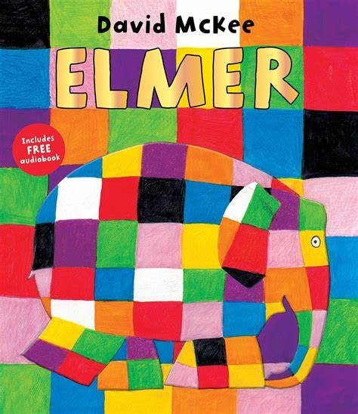 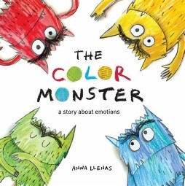 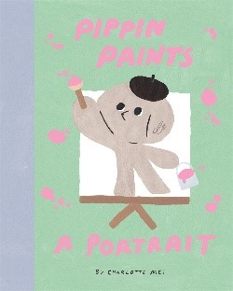
Reading
Knows how we hold a book, which way we turn the pages and that we read from left to right
Enjoys listening to stories
Recognises their name
Can engage in short conversations about stories
Is able to explain what the job of an author and illustrator are
Reads individual letters by saying the sounds for them
Reads phase 2 common exception words
Reads words with 1 syllable
Can answer closed questions involving literal retrieval
Can answer open questions involving literal retrieval
Writing
Participates in fine motor activities
Children can write the first letter of the name
Draws circles, lines and other shapes
Children are able to write initial sounds
Spells words by identifying sounds and writing the letters
Writes some letters accurately
Children can write all of their first name

Expressive Arts and Design:
Use pre-made paints and are able to name colours
Can hold a paintbrush in the palm of their hand
Print with large blocks and larger sponges
Makes marks. Draws circles and lines.
Builds towers by stackings objects
Explores instruments and is beginning to name them (drum, tambourine, maraca, triangle...)
Knows some words when singing
Plays with familiar resources
Able to mix primary colours to make secondary colours
Can use thin brushes to add detail
Print with small blocks, small sponges, fruit, shapes and other resources
Draws potato people (no neck or body)
Children are able to draw simple things from memory
Adds other materials to develop models (tissue paper, glitter...)
Builds simple models using walls, roofs and towers.
Manipulates clay (rolls, cuts, squashes, pinches, twists...)
Is able to name a wide variety of instruments (also including chime bars, glockenspiels, xylophones)
Plays a given instrument to a simple beat
Sings in a group, trying to keep in time
Participates in small world play related to rhymes and stories

Understanding the World:
Past and Present
Able to say who they are and who they live with
Sequence family members by size and name (baby, child, adult)
Comments on fictional characters in stories
Can talk about past and upcoming events with their immediate family
Is able to discuss different occupations of family members
Sequence family members, explaining who they are (baby, toddler, child, teenager, adult, elderly)
Geography
Knows what a map is used for
Knows where they live (house, flat, bungalow)
Can articulate what daily life is like for them in our country
Talk about what they see in their own environment (school/home) using a wide vocabulary
Identifies features on a simple map – in familiar environments such as the classroom and outdoors
Can explain features of other homes
Talk about local environments (their road, the park, library,
The Natural World
Explores how things work
Uses senses in hands on exploration
Understands that the weather changes and that in different countries you have different weather
Understands the difference between plants and animals
Can identify what you need to wear for each season and why
Can name their 5 senses
Explores and talks about forces (push and pull)
People, Cultures and Communities
Talk about our families and our town
Know some similarities and differences between my family and my friends
Comments on recent pictures of experiences in their own life. “This was me at the farm...”
Knows that there are special places of worship
Knows that there are differences between what people believe
Comments on recent pictures of celebrations in their own life. “This was me celebrating Diwali”
Developing positive attitudes about differences between people

How do I express myself?
Colours
Little Tors
OUR learning map
term – Autumn 1 – 2023
Pre-school & Reception

